|  |  |
| --- | --- |
|  | **BAHRIA UNIVERSITY,**  **(Karachi Campus)**  *Department of Software Engineering*  **Assignment#03 (CLO 3) – Spring 2021** |

COURSE TITLE: **Introduction to Software Engineering** COURSE CODE: **SEN-334**

Class:  **BSE 2B** Shift: **Morning**

Course Instructor: **Engr. Mobeen Nazar** Assignment Date: **30-May-2021**Max. Marks: **10 Points** Assignment Due: **7-June-2021**

**Question: Create a detailed work breakdown structure of the topic you have chosen in the groups:**

**Topic: Online Car booking apps**

* TALHA ZAFAR
* MUHAMMAD MUAZ SHAHZAD
* SHAHAB TAHIR

  
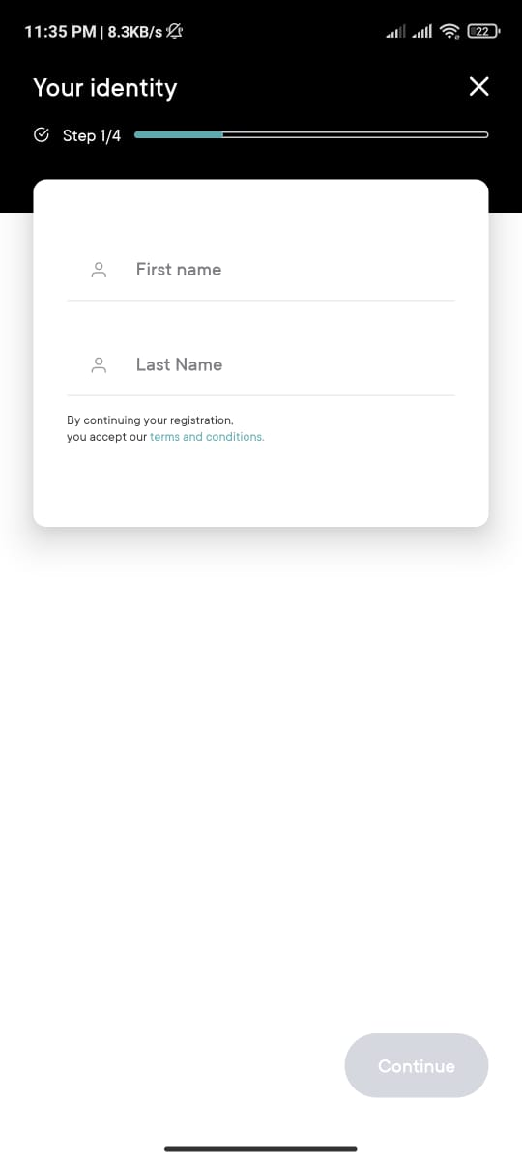  
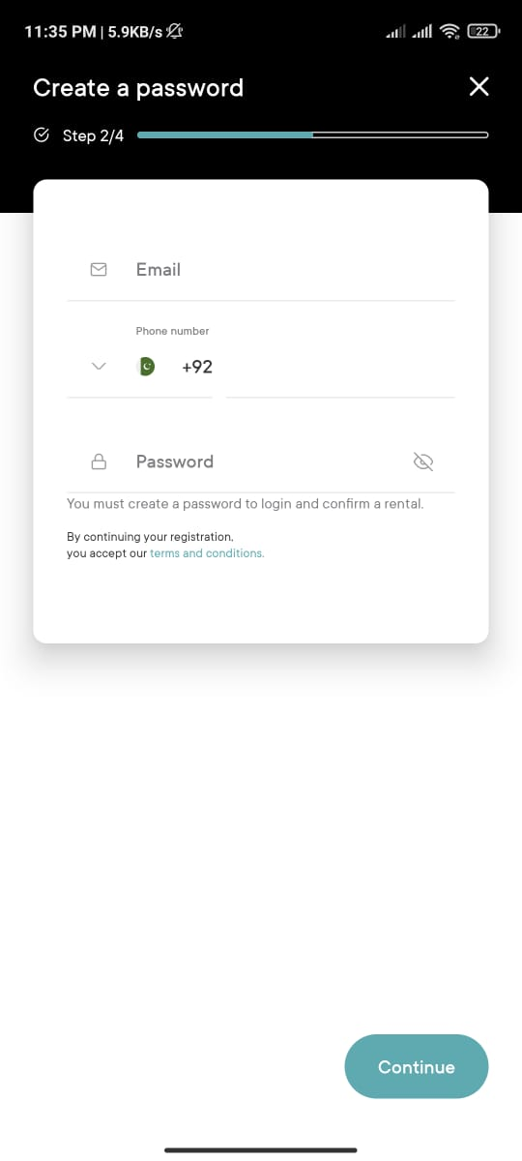  
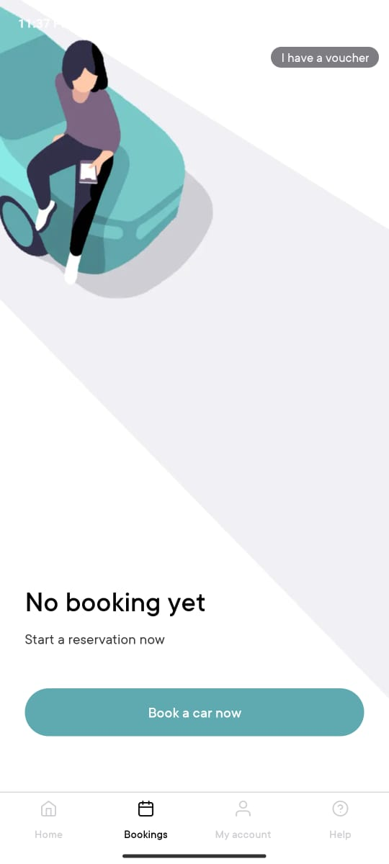

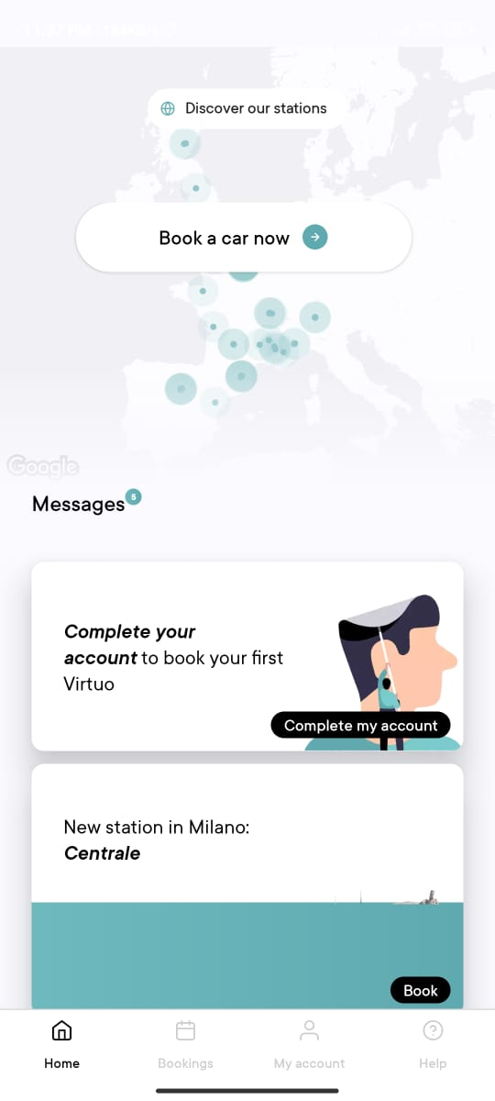

**WBS:**

